**UNIVERSITY OF CALIFORNIA, IRVINE (UCI)**

**COURSE - BUSINESS INTELLIGENCE AND VISUAL ANALYTICS**

**DESIGN AND IMPLEMENTATION OF DASHBOARD IN SAS VISUAL ANALYTICS**

**App Name - SaSSyS Data Analytics**

**Database Driven and Integrated**

**Highly Interactive Software Design with Simple-to-use Features.**

**Database Engine: MySQL Engine**

**Technologies Employed: HTML5, CSS3, Javascript, PhP, MySQL, PhPMyAdmin Page, Wamp Server etc.**

**Developed by Engr. Emmanuel Abayomi Olasehinde.**

**My GITHUB Account -** [**https://github.com/emmanuel1985feb/emmanuel1985feb/tree/main**](https://github.com/emmanuel1985feb/emmanuel1985feb/tree/main)

**All the files for the SaSSyS Data Analytics Application has been uploaded by me to my GITHUB account page.**

**Index.php page Snapshots**

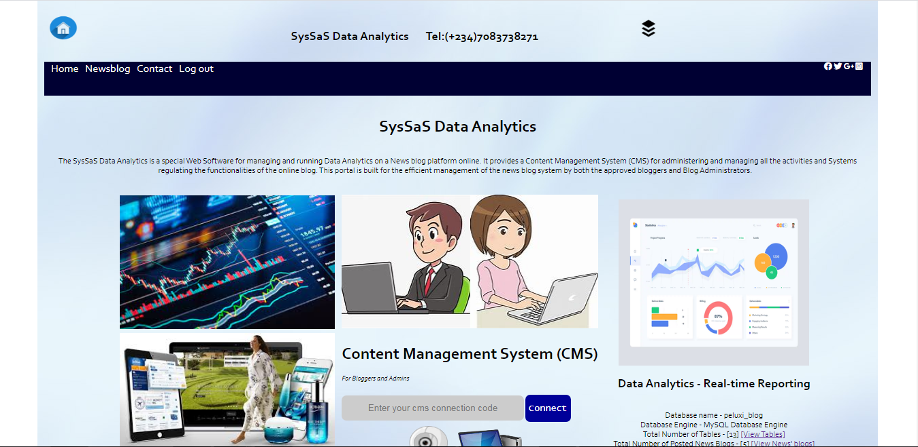

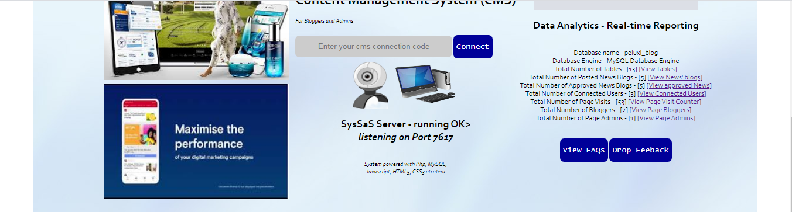





**Sas_newsblog.php page Snapshots**

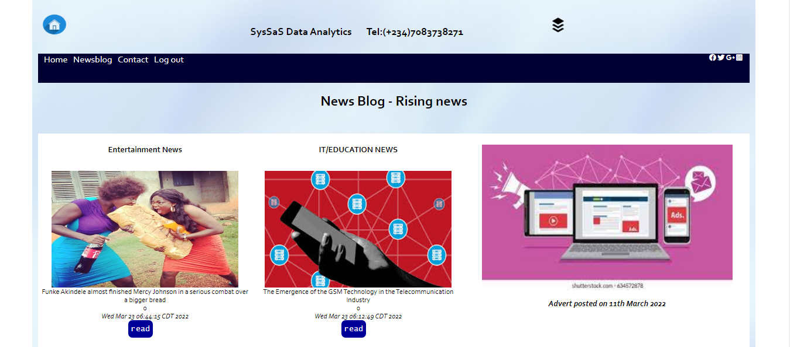

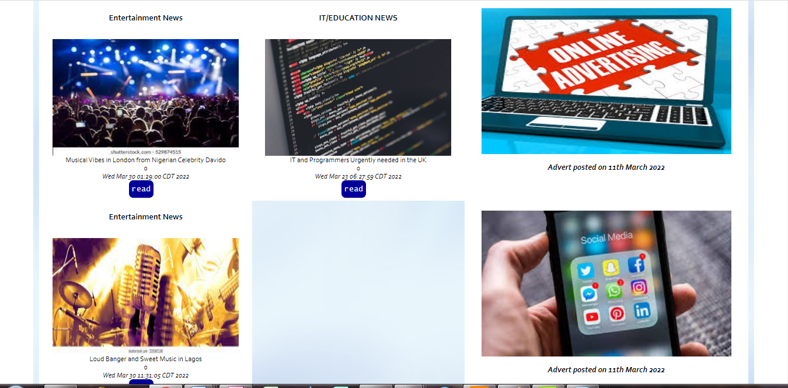

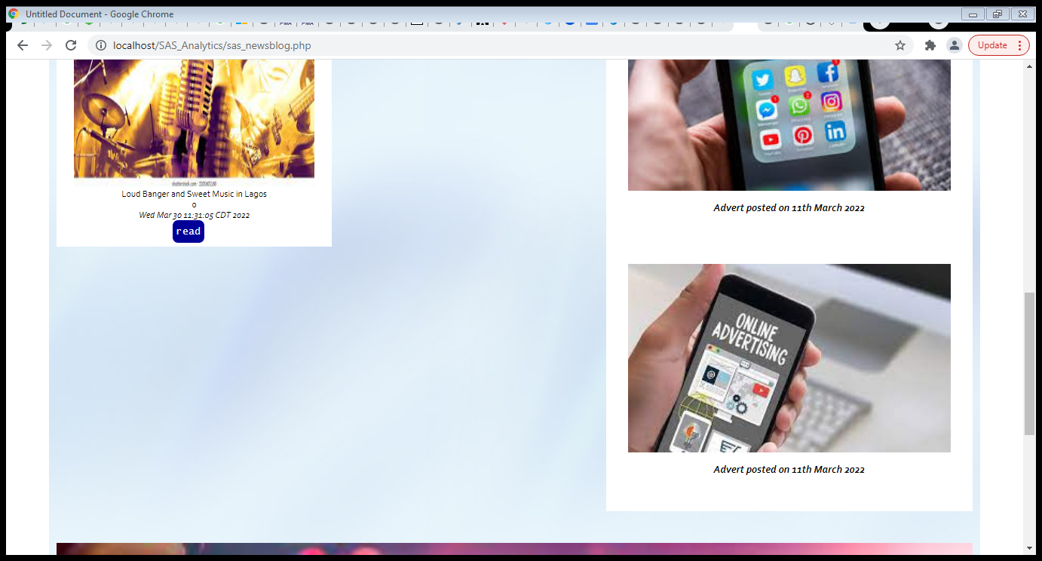



**newsreaderpage.php page Snapshots**

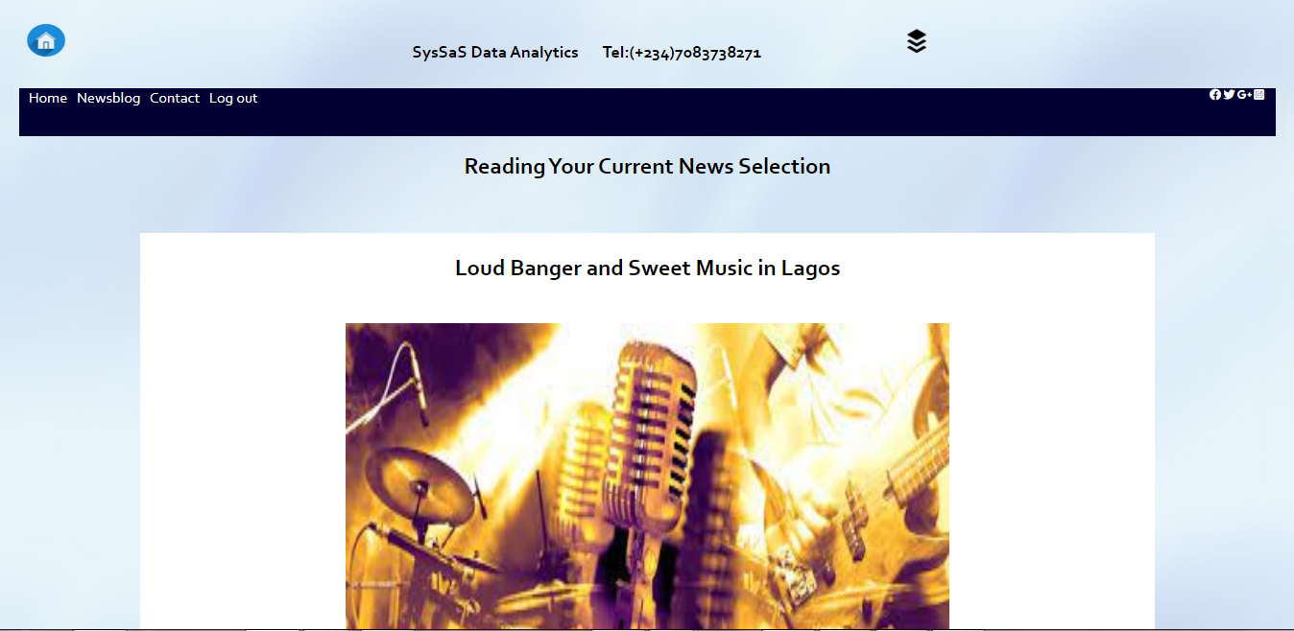

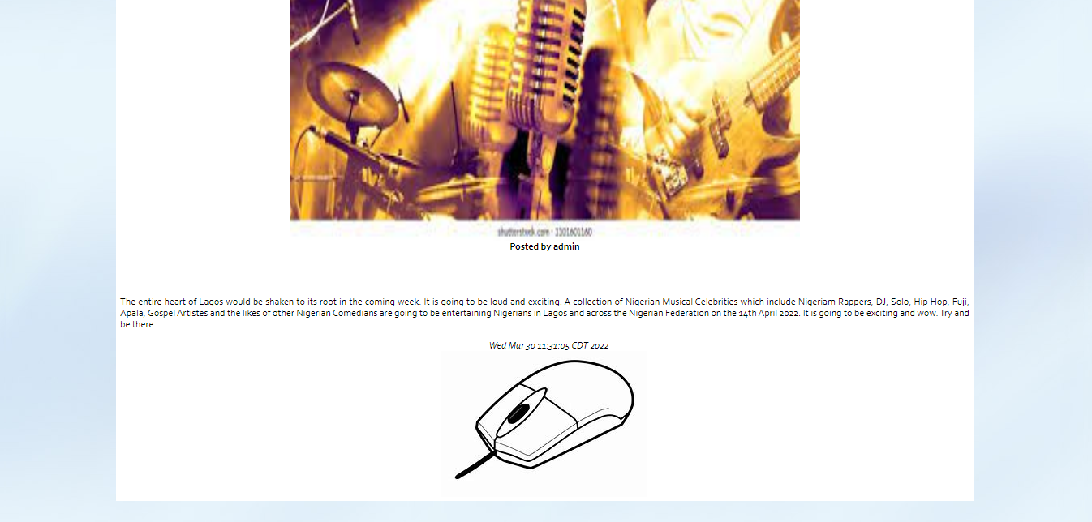

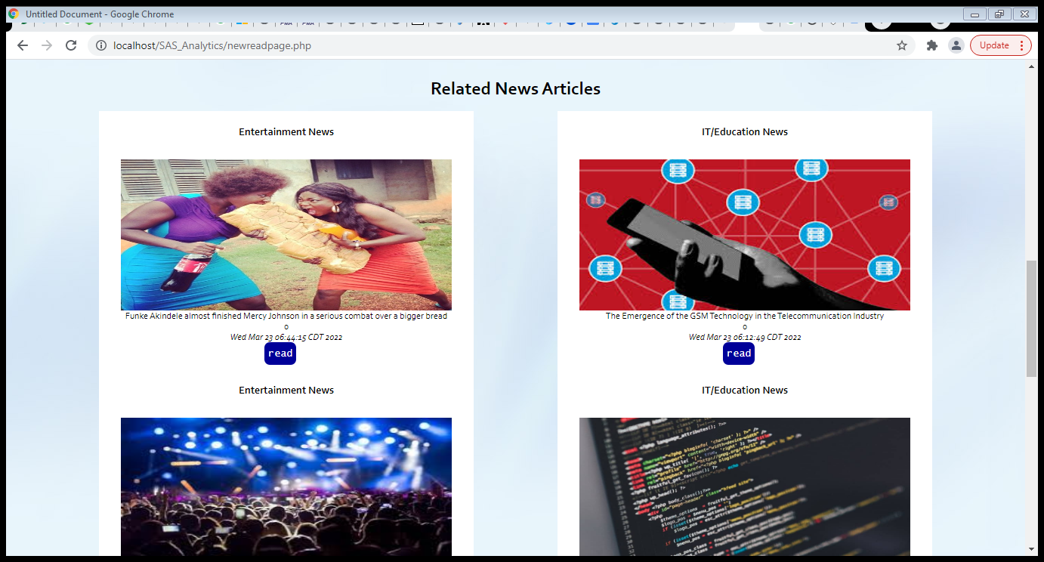

**faq.php page Snapshots**

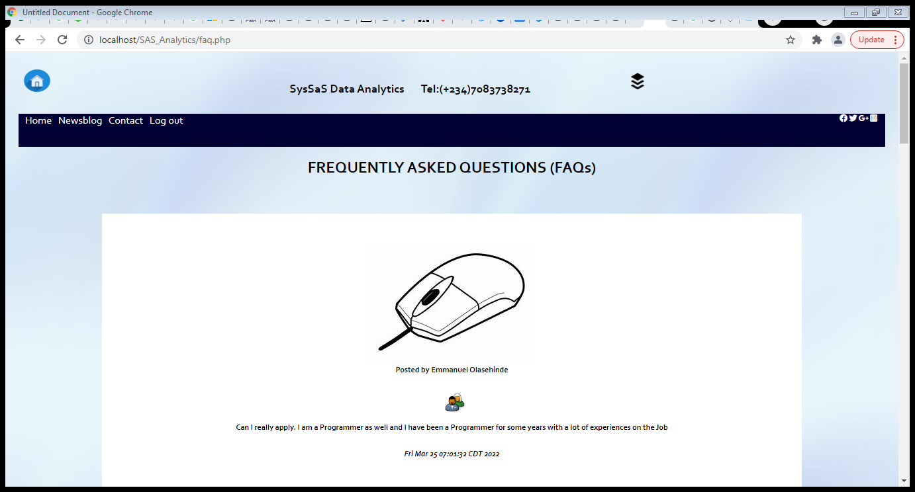

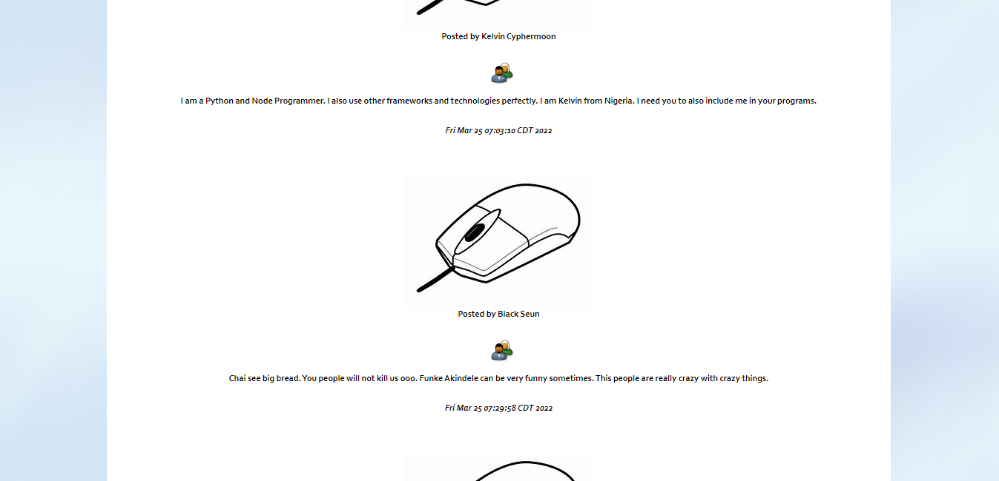

**contact.php page Snapshots**

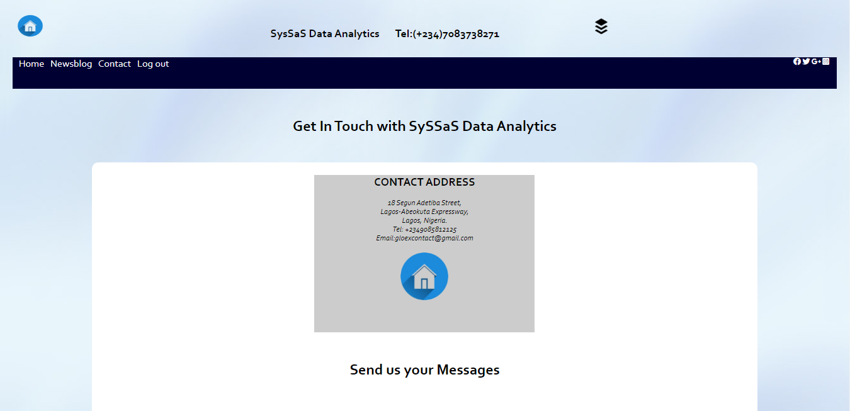

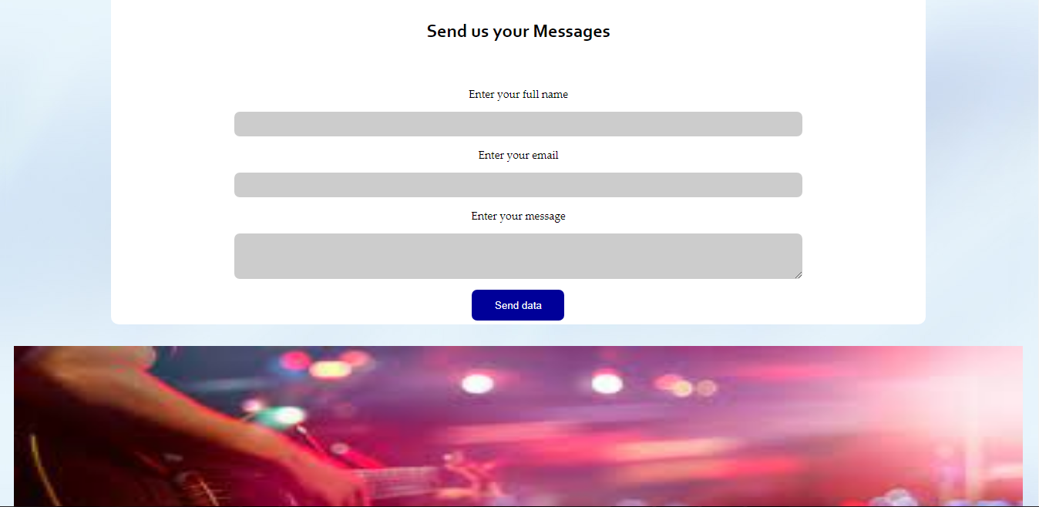



**logout.php page Snapshots**

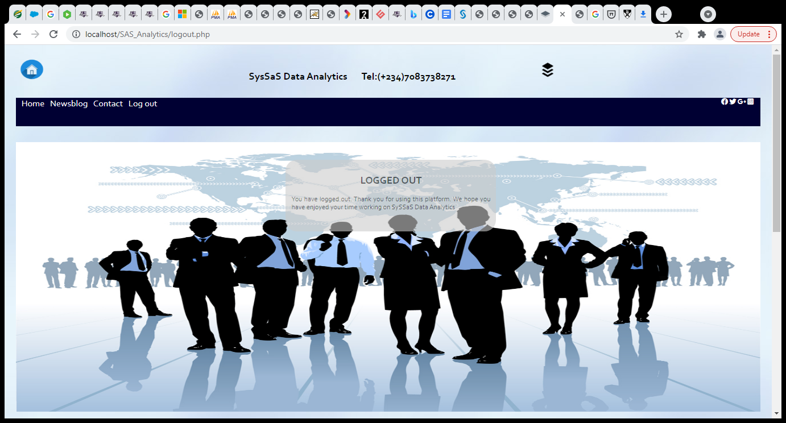

**Database Backend Snapshots**

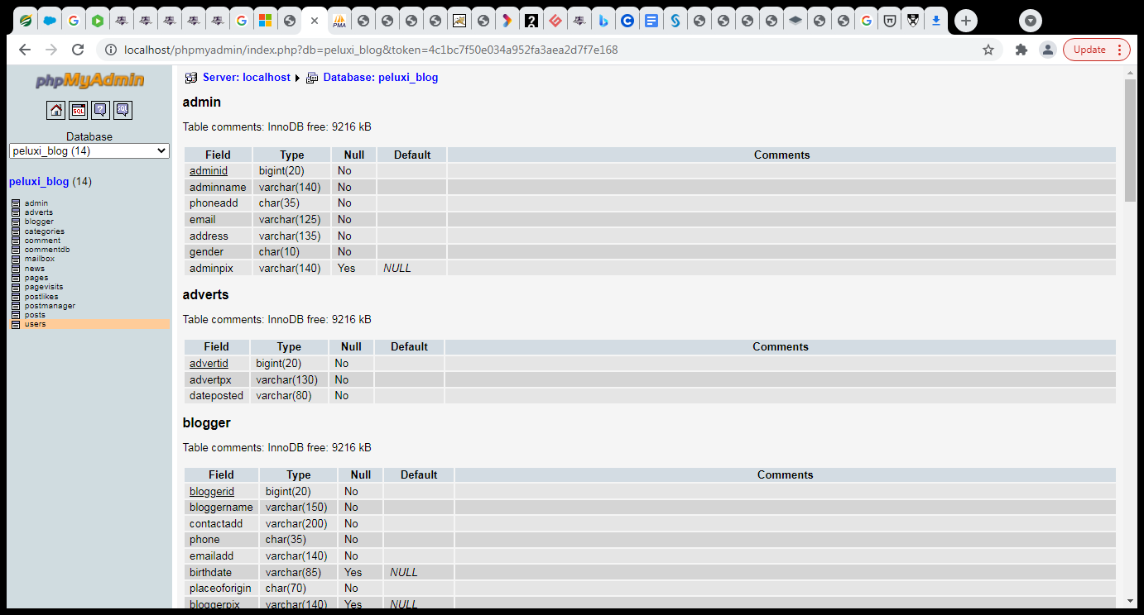

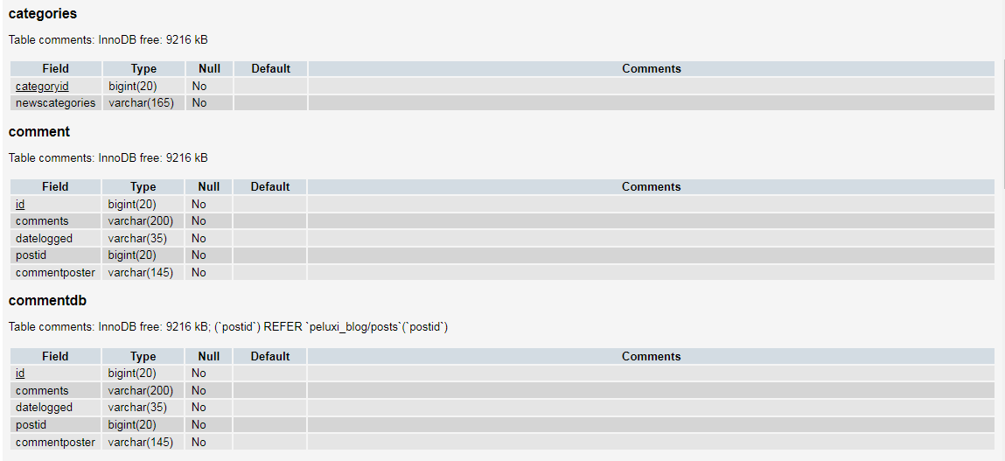

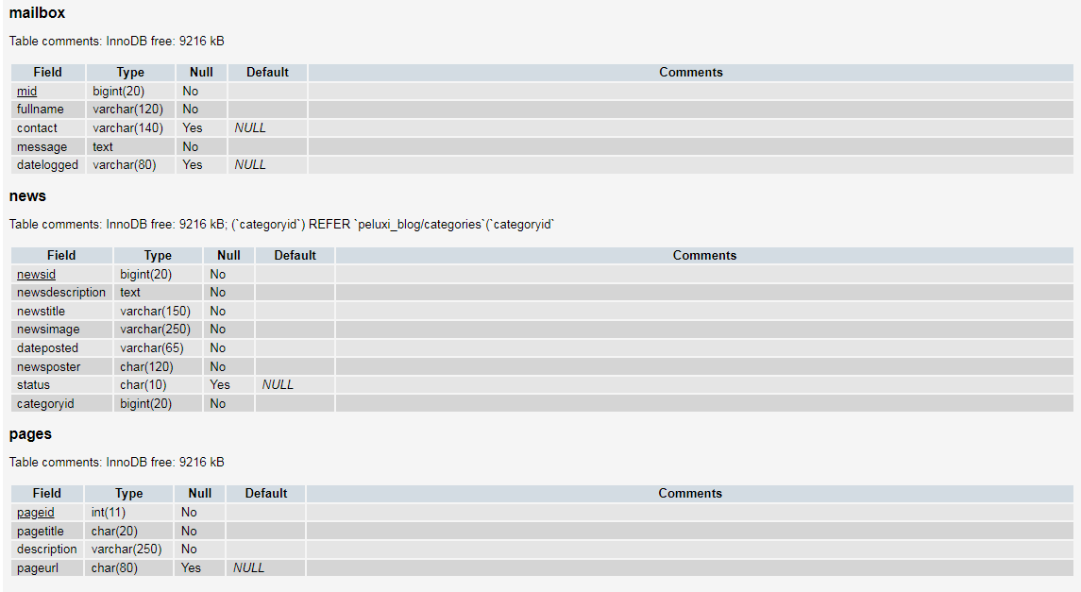

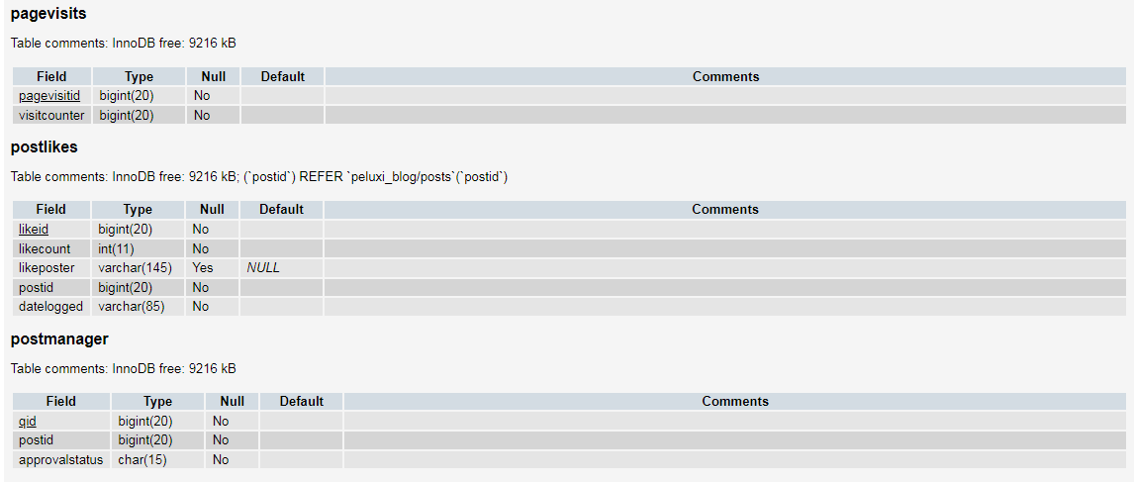

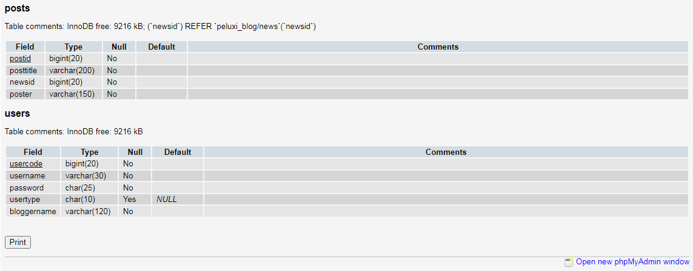

**Database Table [news] with Data Snapshots**

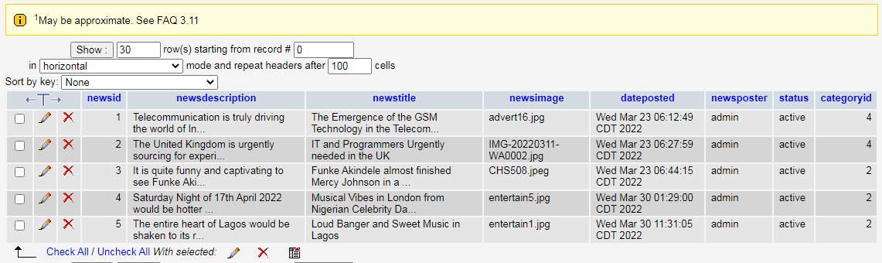

**DDL and DML SQL Source Codes for the MySQL Database Design**

-- phpMyAdmin SQL Dump

-- version 2.11.6

-- http://www.phpmyadmin.net

--

-- Host: localhost

-- Generation Time: Mar 30, 2022 at 03:30 PM

-- Server version: 5.0.51

-- PHP Version: 5.2.6

SET SQL_MODE="NO_AUTO_VALUE_ON_ZERO";

--

-- Database: `peluxi_blog`

--

-- --------------------------------------------------------

--

-- Table structure for table `admin`

--

CREATE TABLE `admin` (

`adminid` bigint(20) NOT NULL auto_increment,

`adminname` varchar(140) NOT NULL,

`phoneadd` char(35) NOT NULL,

`email` varchar(125) NOT NULL,

`address` varchar(135) NOT NULL,

`gender` char(10) NOT NULL,

`adminpix` varchar(140) default NULL,

PRIMARY KEY (`adminid`)

) ENGINE=InnoDB DEFAULT CHARSET=latin1 AUTO_INCREMENT=2 ;

--

-- Dumping data for table `admin`

--

INSERT INTO `admin` (`adminid`, `adminname`, `phoneadd`, `email`, `address`, `gender`, `adminpix`) VALUES

(1, 'Emmanuel Olasehinde', '+2349085812125', 'gloexcontact@gmail.com', '18 Segun Adetiba Street, Ajegunle Ilo, Lagos', 'Male', NULL);

-- --------------------------------------------------------

--

-- Table structure for table `adverts`

--

CREATE TABLE `adverts` (

`advertid` bigint(20) NOT NULL auto_increment,

`advertpx` varchar(130) NOT NULL,

`dateposted` varchar(80) NOT NULL,

PRIMARY KEY (`advertid`)

) ENGINE=InnoDB DEFAULT CHARSET=latin1 AUTO_INCREMENT=21 ;

--

-- Dumping data for table `adverts`

--

INSERT INTO `adverts` (`advertid`, `advertpx`, `dateposted`) VALUES

(1, 'advert1.jpg', '11th March 2022'),

(2, 'advert2.jpg', '11th March 2022'),

(3, 'advert3.jpg', '11th March 2022'),

(4, 'advert4.jpg', '11th March 2022'),

(5, 'advert5.jpg', '11th March 2022'),

(6, 'advert6.jpg', '11th March 2022'),

(7, 'advert7.jpg', '11th March 2022'),

(8, 'advert8.jpg', '11th March 2022'),

(9, 'advert9.jpg', '11th March 2022'),

(10, 'advert10.jpg', '11th March 2022'),

(11, 'advert11.jpg', '11th March 2022'),

(12, 'advert12.jpg', '11th March 2022'),

(13, 'advert13.jpg', '11th March 2022'),

(14, 'advert14.jpg', '11th March 2022'),

(15, 'advert15.jpg', '11th March 2022'),

(16, 'advert16.jpg', '11th March 2022'),

(17, 'advert17.jpg', '11th March 2022'),

(18, 'advert18.jpg', '11th March 2022'),

(19, 'advert19.jpg', '11th March 2022'),

(20, 'advert20.jpg', '11th March 2022');

-- --------------------------------------------------------

--

-- Table structure for table `blogger`

--

CREATE TABLE `blogger` (

`bloggerid` bigint(20) NOT NULL auto_increment,

`bloggername` varchar(150) NOT NULL,

`contactadd` varchar(200) NOT NULL,

`phone` char(35) NOT NULL,

`emailadd` varchar(140) NOT NULL,

`birthdate` varchar(85) default NULL,

`placeoforigin` char(70) NOT NULL,

`bloggerpix` varchar(140) default NULL,

`gender` char(20) NOT NULL,

PRIMARY KEY (`bloggerid`)

) ENGINE=InnoDB DEFAULT CHARSET=latin1 AUTO_INCREMENT=8 ;

--

-- Dumping data for table `blogger`

--

INSERT INTO `blogger` (`bloggerid`, `bloggername`, `contactadd`, `phone`, `emailadd`, `birthdate`, `placeoforigin`, `bloggerpix`, `gender`) VALUES

(6, 'Semiu Adeola', '45 Ferari Street, Alakuko Lagos', '+2349098387263', 'semiu121@gmail.com', '15th September 1996', 'Lagos', NULL, 'Male'),

(7, 'Henry Douglas', '6 Kelani Close, Opposite Shoprite, Alausa Lagos', '+2349093827829', 'henrydouglasbrownson@gmail.com', '2nd May 1975', 'Kogi State, Nigeria', NULL, 'Male');

-- --------------------------------------------------------

--

-- Table structure for table `categories`

--

CREATE TABLE `categories` (

`categoryid` bigint(20) NOT NULL auto_increment,

`newscategories` varchar(165) NOT NULL,

PRIMARY KEY (`categoryid`)

) ENGINE=InnoDB DEFAULT CHARSET=latin1 AUTO_INCREMENT=7 ;

--

-- Dumping data for table `categories`

--

INSERT INTO `categories` (`categoryid`, `newscategories`) VALUES

(1, 'Societal News'),

(2, 'Entertainment'),

(3, 'Political'),

(4, 'IT News/Education'),

(5, 'Business'),

(6, 'Sport');

-- --------------------------------------------------------

--

-- Table structure for table `comment`

--

CREATE TABLE `comment` (

`id` bigint(20) NOT NULL auto_increment,

`comments` varchar(200) NOT NULL,

`datelogged` varchar(35) NOT NULL,

`postid` bigint(20) NOT NULL,

`commentposter` varchar(145) NOT NULL,

PRIMARY KEY (`id`)

) ENGINE=InnoDB DEFAULT CHARSET=latin1 AUTO_INCREMENT=6 ;

--

-- Dumping data for table `comment`

--

INSERT INTO `comment` (`id`, `comments`, `datelogged`, `postid`, `commentposter`) VALUES

(2, ' Can I really apply. I am a Programmer as well and I have been a Programmer for some years with a lot of experiences on the Job', 'Fri Mar 25 07:01:32 CDT 2022', 2, 'Emmanuel Olasehinde'),

(3, ' I am a Python and Node Programmer. I also use other frameworks and technologies perfectly. I am Kelvin from Nigeria. I need you to also include me in your programs.', 'Fri Mar 25 07:03:10 CDT 2022', 2, 'Kelvin Cyphermoon'),

(4, ' Chai see big bread. You people will not kill us ooo. Funke Akindele can be very funny sometimes. This people are really crazy with crazy things.', 'Fri Mar 25 07:29:58 CDT 2022', 3, 'Black Seun'),

(5, ' Haahaa...I have never seen this big bread before. Is it for real? This is really serious and the fact that they were both fighting over it makes the whole drama so funny and laughable', 'Fri Mar 25 07:31:53 CDT 2022', 3, 'Pelumi Pelumi');

-- --------------------------------------------------------

--

-- Table structure for table `commentdb`

--

CREATE TABLE `commentdb` (

`id` bigint(20) NOT NULL auto_increment,

`comments` varchar(200) NOT NULL,

`datelogged` varchar(35) NOT NULL,

`postid` bigint(20) NOT NULL,

`commentposter` varchar(145) NOT NULL,

PRIMARY KEY (`id`),

KEY `fkpm` (`postid`)

) ENGINE=InnoDB DEFAULT CHARSET=latin1 AUTO_INCREMENT=2 ;

--

-- Dumping data for table `commentdb`

--

INSERT INTO `commentdb` (`id`, `comments`, `datelogged`, `postid`, `commentposter`) VALUES

(1, ' Wow this is a great news. I am so elated and I really love this news so much. It shows one of the admirable developments we have had in Nigeria during the regime of Obasanjo.', 'Fri Mar 25 06:48:50 CDT 2022', 1, 'Emmanuel Olasehinde');

-- --------------------------------------------------------

--

-- Table structure for table `mailbox`

--

CREATE TABLE `mailbox` (

`mid` bigint(20) NOT NULL auto_increment,

`fullname` varchar(120) NOT NULL,

`contact` varchar(140) default NULL,

`message` text NOT NULL,

`datelogged` varchar(80) default NULL,

PRIMARY KEY (`mid`)

) ENGINE=InnoDB DEFAULT CHARSET=latin1 AUTO_INCREMENT=3 ;

--

-- Dumping data for table `mailbox`

--

INSERT INTO `mailbox` (`mid`, `fullname`, `contact`, `message`, `datelogged`) VALUES

(1, 'Yemi Oladele', 'yemiolad45@gmail.com', 'Hello pls I want to also know how to build and design a news blog. I would not mind paying the charges. Thanks.', '22-03-30 12:26:36 pm'),

(2, 'Yemi Oladele', 'yemiolad45@gmail.com', 'Hello pls I want to also know how to build and design a news blog. I would not mind paying the charges. Thanks.', '22-03-30 12:33:12 pm');

-- --------------------------------------------------------

--

-- Table structure for table `news`

--

CREATE TABLE `news` (

`newsid` bigint(20) NOT NULL auto_increment,

`newsdescription` text NOT NULL,

`newstitle` varchar(150) NOT NULL,

`newsimage` varchar(250) NOT NULL,

`dateposted` varchar(65) NOT NULL,

`newsposter` char(120) NOT NULL,

`status` char(10) default NULL,

`categoryid` bigint(20) NOT NULL,

PRIMARY KEY (`newsid`),

KEY `fk_newslink_002` (`categoryid`)

) ENGINE=InnoDB DEFAULT CHARSET=latin1 AUTO_INCREMENT=6 ;

--

-- Dumping data for table `news`

--

INSERT INTO `news` (`newsid`, `newsdescription`, `newstitle`, `newsimage`, `dateposted`, `newsposter`, `status`, `categoryid`) VALUES

(1, 'Telecommunication is truly driving the world of Information and Communication Technology in diverse ways. It has undoubtedly improved and transformed the way we do things and also communicate. Before the advent of mobile networks and telephony, communicating has been very expensive and somewhat difficult. Back then, you really have to spend so much to install phone services in your office or residential apartment. Only organizations and those who were financially bouyant could afford to buy a Telephone set that was mainly a Landline phone from NITEL. But during the regime of the past President of the Federal Republic of Nigeria, President Olusegun Obasanjo, Telecommunication advanced through the emergence of the GSM Technology, which practically made telecommunication affordable and accessible to all.', 'The Emergence of the GSM Technology in the Telecommunication Industry', 'advert16.jpg', 'Wed Mar 23 06:12:49 CDT 2022', 'admin', 'active', 4),

(2, 'The United Kingdom is urgently sourcing for experienced Computer Programmers who can develop software solutions for various deployment platforms such as Mobile, Android, Cloud, Desktop and the World Wide Web (WWW) Platform. The Queen of England had recently announced through the Queens Media forum and news platform that the United Kingdom would be needing about 1.5 Millions Programmers and other IT Specialists to fill the various Job Vacancies that have been created so far by the United Kingdom Bureau of Works and Labor. Therefore in lieu of this opportunity and employment schemes, applicants are invited all over the world for automatic or instant employment. For the International Applicants, there is the available option for a fully funded all-expense paid Travel and Visa Processing, which would be automatically given to all eligible and legitimate applicant. There is no bias or sentimentalism attached to gender. Anyone is liable or eligible to apply. The COVID-19 pandemic has stimulated the United Kingdom to think of coming up with strategic plans and policies that would help people from all over the world to fulfil their good dreams and hopes in the United Kingdom and also contribute immensely to the general and socio-economic development of the United Kingdom.', 'IT and Programmers Urgently needed in the UK', 'IMG-20220311-WA0002.jpg', 'Wed Mar 23 06:27:59 CDT 2022', 'admin', 'active', 4),

(3, 'It is quite funny and captivating to see Funke Akindele fighting over a big-sized bread with Mercy Johnson. Ever since the launching of the film titled, At last, we made it, Nigerians have been wondering about the size of the bread and perhaps the exact bakery where such a strange and big bread was baked. Funke Akindele has always been funny and she often give her best to acting whenever she had the opportunity of acting. The way she fought over bread was both comic, funny and more or less a rib-cracking performance. Mercy Johnson also showed super performance as usual, the whole contents and participating actors in the Film were intriguing and marvellous. This is no doubt one of the best films in Nigeria, atleast in the past 3 decades, we have never seen such an energetic and professional performance. It is really laudable and heart-pleasing that Nigeria Movie Industry, popularly known as Nollywood is fast improving in all aspects of Film-making and the entire Movie Industry. Little wonder, the Nollywood Industry won several African, National and International Awards for its super-performance and excellent commitment to producing and releasing excellent films and productions that can stand and compete efficiently with Bollywood and Hollywood films.', 'Funke Akindele almost finished Mercy Johnson in a serious combat over a bigger bread', 'CHS508.jpeg', 'Wed Mar 23 06:44:15 CDT 2022', 'admin', 'active', 2),

(4, 'Saturday Night of 17th April 2022 would be hotter than fire. Davido popularly known as OBO has promised to raze the roof with an electrifying performance that would shock every of his millions of fans across the world more than ever. He is already engaging and collaborating with the likes of Wizkid, Zazoo Zeh Crooner and the others to make the show really splendid and memorable. It is going to be really hot indeed.\r\nDavid is a wonderful musician and I am sure he is going to give a big banger.', 'Musical Vibes in London from Nigerian Celebrity Davido', 'entertain5.jpg', 'Wed Mar 30 01:29:00 CDT 2022', 'admin', 'active', 2),

(5, 'The entire heart of Lagos would be shaken to its root in the coming week. It is going to be loud and exciting. A collection of Nigerian Musical Celebrities which include Nigeriam Rappers, DJ, Solo, Hip Hop, Fuji, Apala, Gospel Artistes and the likes of other Nigerian Comedians are going to be entertaining Nigerians in Lagos and across the Nigerian Federation on the 14th April 2022. It is going to be exciting and wow. Try and be there.', 'Loud Banger and Sweet Music in Lagos', 'entertain1.jpg', 'Wed Mar 30 11:31:05 CDT 2022', 'admin', 'active', 2);

-- --------------------------------------------------------

--

-- Table structure for table `pages`

--

CREATE TABLE `pages` (

`pageid` int(11) NOT NULL auto_increment,

`pagetitle` char(20) NOT NULL,

`description` varchar(250) NOT NULL,

`pageurl` char(80) default NULL,

PRIMARY KEY (`pageid`)

) ENGINE=InnoDB DEFAULT CHARSET=latin1 AUTO_INCREMENT=1 ;

--

-- Dumping data for table `pages`

--

-- --------------------------------------------------------

--

-- Table structure for table `pagevisits`

--

CREATE TABLE `pagevisits` (

`pagevisitid` bigint(20) NOT NULL auto_increment,

`visitcounter` bigint(20) NOT NULL,

PRIMARY KEY (`pagevisitid`)

) ENGINE=InnoDB DEFAULT CHARSET=latin1 AUTO_INCREMENT=56 ;

--

-- Dumping data for table `pagevisits`

--

INSERT INTO `pagevisits` (`pagevisitid`, `visitcounter`) VALUES

(1, 1),

(2, 1),

(3, 1),

(4, 1),

(5, 1),

(6, 1),

(7, 1),

(8, 1),

(9, 1),

(10, 1),

(11, 1),

(12, 1),

(13, 1),

(14, 1),

(15, 1),

(16, 1),

(17, 1),

(18, 1),

(19, 1),

(20, 1),

(21, 1),

(22, 1),

(23, 1),

(24, 1),

(25, 1),

(26, 1),

(27, 1),

(28, 1),

(29, 1),

(30, 1),

(31, 1),

(32, 1),

(33, 1),

(34, 1),

(35, 1),

(36, 1),

(37, 1),

(38, 1),

(39, 1),

(40, 1),

(41, 1),

(42, 1),

(43, 1),

(44, 1),

(45, 1),

(46, 1),

(47, 1),

(48, 1),

(49, 1),

(50, 1),

(51, 1),

(52, 1),

(53, 1),

(54, 1),

(55, 1);

-- --------------------------------------------------------

--

-- Table structure for table `postlikes`

--

CREATE TABLE `postlikes` (

`likeid` bigint(20) NOT NULL auto_increment,

`likecount` int(11) NOT NULL,

`likeposter` varchar(145) default NULL,

`postid` bigint(20) NOT NULL,

`datelogged` varchar(85) NOT NULL,

PRIMARY KEY (`likeid`),

KEY `fkdm` (`postid`)

) ENGINE=InnoDB DEFAULT CHARSET=latin1 AUTO_INCREMENT=9 ;

--

-- Dumping data for table `postlikes`

--

INSERT INTO `postlikes` (`likeid`, `likecount`, `likeposter`, `postid`, `datelogged`) VALUES

(1, 1, NULL, 2, 'Fri Mar 25 09:00:46 CDT 2022'),

(2, 1, NULL, 2, 'Fri Mar 25 09:01:46 CDT 2022'),

(3, 1, NULL, 2, 'Fri Mar 25 09:04:22 CDT 2022'),

(4, 1, NULL, 3, 'Fri Mar 25 09:16:38 CDT 2022'),

(5, 1, NULL, 3, 'Fri Mar 25 09:30:45 CDT 2022'),

(6, 1, NULL, 1, 'Fri Mar 25 09:32:07 CDT 2022'),

(7, 1, NULL, 1, 'Fri Mar 25 09:36:30 CDT 2022'),

(8, 1, NULL, 3, 'Sat Mar 26 07:05:29 CDT 2022');

-- --------------------------------------------------------

--

-- Table structure for table `postmanager`

--

CREATE TABLE `postmanager` (

`qid` bigint(20) NOT NULL auto_increment,

`postid` bigint(20) NOT NULL,

`approvalstatus` char(15) NOT NULL,

PRIMARY KEY (`qid`),

KEY `fksj` (`postid`)

) ENGINE=InnoDB DEFAULT CHARSET=latin1 AUTO_INCREMENT=19 ;

--

-- Dumping data for table `postmanager`

--

INSERT INTO `postmanager` (`qid`, `postid`, `approvalstatus`) VALUES

(14, 1, 'Approved'),

(15, 2, 'Approved'),

(16, 3, 'Approved'),

(17, 4, 'Approved'),

(18, 5, 'Approved');

-- --------------------------------------------------------

--

-- Table structure for table `posts`

--

CREATE TABLE `posts` (

`postid` bigint(20) NOT NULL auto_increment,

`posttitle` varchar(200) NOT NULL,

`newsid` bigint(20) NOT NULL,

`poster` varchar(150) NOT NULL,

PRIMARY KEY (`postid`),

KEY `FKJ` (`newsid`)

) ENGINE=InnoDB DEFAULT CHARSET=latin1 AUTO_INCREMENT=6 ;

--

-- Dumping data for table `posts`

--

INSERT INTO `posts` (`postid`, `posttitle`, `newsid`, `poster`) VALUES

(1, 'The Emergence of the GSM Technology in the Telecommunication Industry', 1, 'admin'),

(2, 'IT and Programmers Urgently needed in the UK', 2, 'admin'),

(3, 'Funke Akindele almost finished Mercy Johnson in a serious combat over a bigger bread', 3, 'admin'),

(4, 'Musical Vibes in London from Nigerian Celebrity Davido', 4, 'admin'),

(5, 'Loud Banger and Sweet Music in Lagos', 5, 'admin');

-- --------------------------------------------------------

--

-- Table structure for table `users`

--

CREATE TABLE `users` (

`usercode` bigint(20) NOT NULL auto_increment,

`username` varchar(30) NOT NULL,

`password` char(25) NOT NULL,

`usertype` char(10) default NULL,

`bloggername` varchar(120) NOT NULL,

PRIMARY KEY (`usercode`)

) ENGINE=InnoDB DEFAULT CHARSET=latin1 AUTO_INCREMENT=4 ;

--

-- Dumping data for table `users`

--

INSERT INTO `users` (`usercode`, `username`, `password`, `usertype`, `bloggername`) VALUES

(1, 'georgewellin', 'georgewellin', 'blogger', 'George'),

(2, 'fredspeaker', 'fredspeaker', 'blogger', 'Fredrick'),

(3, 'lawal', 'lawal', 'blogger', 'lawal ambode');

--

-- Constraints for dumped tables

--

--

-- Constraints for table `commentdb`

--

ALTER TABLE `commentdb`

ADD CONSTRAINT `commentdb_ibfk_1` FOREIGN KEY (`postid`) REFERENCES `posts` (`postid`);

--

-- Constraints for table `news`

--

ALTER TABLE `news`

ADD CONSTRAINT `fk_newslink_002` FOREIGN KEY (`categoryid`) REFERENCES `categories` (`categoryid`);

--

-- Constraints for table `postlikes`

--

ALTER TABLE `postlikes`

ADD CONSTRAINT `postlikes_ibfk_1` FOREIGN KEY (`postid`) REFERENCES `posts` (`postid`);

--

-- Constraints for table `posts`

--

ALTER TABLE `posts`

ADD CONSTRAINT `posts_ibfk_1` FOREIGN KEY (`newsid`) REFERENCES `news` (`newsid`);

**Source Codes for the index.php page**

<?php include('mysqliconnector.php'); ?>

<?php

//Registering Unique Page Visits

$pagevisit_counter = 1;

//$pagevisit_counter = $pagevisit_counter + 1;

$push = "INSERT INTO `pagevisits` (

`pagevisitid` ,

`visitcounter`

)

VALUES (

NULL , $pagevisit_counter);";

$execu = $dblink -> query($push);

if($execu){

//echo $pagevisit_counter;

}

?>

<?php

//Counting Page Visits from databank

$visitcounter = 0;

$visitq = "Select * from pagevisits;";

$evta_exec = $dblink -> query($visitq);

if($evta_exec){

while($row = mysqli_fetch_array($evta_exec,MYSQLI_ASSOC)){

$visit = $row['visitcounter'];

$visitcounter = $visitcounter + 1;

}

}

?>

<?php

//Counting Bloggers from databank

$bloggercounter = 0;

$bloggerq = "Select * from blogger;";

$evta_exec = $dblink -> query($bloggerq);

if($evta_exec){

while($row = mysqli_fetch_array($evta_exec,MYSQLI_ASSOC)){

$blogger = $row['bloggername'];

$bloggercounter = $bloggercounter + 1;

}

}

?>

<?php

//Counting Bloggers from databank

$admincounter = 0;

$adminq = "Select * from admin;";

$evta_exec = $dblink -> query($adminq);

if($evta_exec){

while($row = mysqli_fetch_array($evta_exec,MYSQLI_ASSOC)){

$admin = $row['adminname'];

$admincounter = $admincounter + 1;

}

}

?>

<!DOCTYPE html PUBLIC "-//W3C//DTD XHTML 1.0 Transitional//EN" "http://www.w3.org/TR/xhtml1/DTD/xhtml1-transitional.dtd">

<html xmlns="http://www.w3.org/1999/xhtml">

<head>

<meta http-equiv="Content-Type" content="text/html; charset=utf-8" />

<script src="https://kit.fontawesome.com/2ed29b2ae9.js" crossorigin="anonymous"></script>

<title>Untitled Document</title>

<link rel="stylesheet" href="https://cdnjs.cloudflare.com/ajax/libs/font-awesome/4.7.0/css/font-awesome.min.css">

<style type="text/css">

body{

margin:0px;

font-family:Corbel,Book Antiqua;

font-size:12px;

color:#000000;

}

.container{

width:90%;

height:auto;

padding:10px 10px;

background-image:url(SoftBlue.jpg);

margin:0px;

}

.topbar{

width:99%;

height:40px;

color:#000000;

}

#menubar{

width:100%;

height:50px;

background-color:#003;

color:#ffffff;

left:0px;

right:0px;

}

#a{

font-family:Corbel,Book Antiqua;

font-size:16px;

color:#ffffff;

text-decoration:none;

}

ul >li{

display:inline-block;

}

</style>

</head>

<body>

<center>

<div class="container">

<center>

<div class="topbar">

<h2 align="center"> <a href="index.php"> <img src="homeicon-removebg-preview.png" width="42" height="36" style="float:left;clear:both;" /></a>&nbsp;&nbsp;&nbsp;&nbsp;SysSaS Data Analytics &nbsp;&nbsp;&nbsp;&nbsp;&nbsp;&nbsp;Tel:(+234)7083738271 &nbsp;&nbsp;&nbsp;&nbsp;&nbsp;&nbsp;&nbsp;&nbsp;&nbsp;&nbsp;&nbsp;&nbsp;&nbsp;&nbsp;&nbsp;&nbsp;&nbsp;&nbsp;&nbsp;&nbsp;&nbsp;&nbsp;&nbsp;&nbsp;&nbsp;&nbsp;&nbsp;&nbsp;&nbsp;&nbsp;&nbsp;&nbsp;&nbsp;&nbsp;&nbsp;&nbsp;

<a href="#"><img src="buffer.png" width="42" height="36" /></a></h2>

</div>

</center>

<br/><br/>

<div id="menubar">&nbsp;&nbsp;

<span style="float:left;">

&nbsp;&nbsp;&nbsp; <a href="index.php" id="a">Home</a>&nbsp;&nbsp;&nbsp;

<a href="sas_newsblog.php" id="a">Newsblog</a>&nbsp;&nbsp;&nbsp;

<a href="contact.php" id="a">Contact</a>&nbsp;&nbsp;&nbsp;

<a href="logout.php" id="a">Log out</a>&nbsp;&nbsp;&nbsp;

</span>

&nbsp;&nbsp;&nbsp;&nbsp;&nbsp;&nbsp;&nbsp;&nbsp;&nbsp;&nbsp;&nbsp;&nbsp;&nbsp;&nbsp;&nbsp;&nbsp;&nbsp;&nbsp;&nbsp;

<span style="float:right;">

<i class="fa-brands fa-facebook"></i>

<i class="fa-brands fa-twitter"></i>

<i class="fa-brands fa-google-plus"></i>

<i class="fa-brands fa-instagram-square"></i>&nbsp;&nbsp;&nbsp;&nbsp;&nbsp;

</span>

</div>

<br/>

<p align="justify">

<strong><h1>SysSaS Data Analytics</h1></strong> <br/>

The SysSaS Data Analytics is a special Web Software for managing and running Data Analytics on a News blog platform online. It provides a Content Management System (CMS) for administering and managing all the activities and Systems regulating the functionalities of the online blog. This portal is built for the efficient management of the news blog system by both the approved bloggers and Blog Administrators.

&nbsp;&nbsp;

</p>

<div style="width:100%; height:auto; display:inline-block;">

<ul>

<li>

<div style="width:100%;">

<center>

<table width="100%" border="0" cellspacing="2" cellpadding="2">

<tr>

<td>

<img src="downloadjd.jpg" width="100%" height="197"/>

</td>

</tr>

<tr>

<td>

<img src="advert17.jpg" width="100%" height="168"/>

</td>

</tr>

<tr>

<td>

<img src="advert18.jpg" width="100%" height="197"/>

</td>

</tr>

</table>

</center>

</div>

</li>

<li>

<div style="width:100%;">

<center>

<table width="100%" border="0" cellspacing="2" cellpadding="2">

<tr>

<td><img src="OIP (2).jpg" width="50%" height="197" /><img src="OIP (3).jpg" width="50%" height="197" /></td>

</tr>

<tr>

<td>

<p><strong><h1>Content Management System (CMS)</h1></strong>

<sub><em>For Bloggers and Admins</em></sub>

</p></td>

</tr>

<tr>

<td><form action="" method="" enctype="multipart/form-data">

<input type="text" placeholder="Enter your cms connection code" style="width:70%; height:35px;text-align:center;border-style:none; border-color:#CCC; border-radius:7px 7px; background-color:#CCC;" /> <input type="submit" value="Connect"

style="width:auto; height:40px; padding:5px 5px 5px 5px; font-family:'Lucida Console', Monaco, monospace; background-color:#009; color:#FFF; border-style:none; border-color:#009; border-radius:7px 7px;"/>

</form></td>

</tr>

<tr>

<td align="center">

<img src="OIP (6) (1).jpg" width="60px" height="80px" /><img src="computer.png" width="120px" height="80px" /><br/>

<h2>SysSaS Server - running OK><br/>

<em>listening on Port 7617</em></h2 ><br/>

<em><small>System powered with Php, MySQL,<br/> Javascript, HTML5, CSS3 etcetera</small></em>

</td>

</tr>

<tr>

<td>&nbsp;</td>

</tr>

<tr>

<td>&nbsp;</td>

</tr>

</table>

</center>

</div>

</li>

<li>

<div style="width:100%;">

<center>

<p align="center"><img src="dashboard_f_converted_1__converted.png" width="280px" height="245px" /></p>

<h2>Data Analytics - Real-time Reporting</h2><br/>

Database name - peluxi_blog

<br/>

Database Engine - MySQL Database Engine<br/>

Total Number of Tables - [13] <a href="#">[View Tables]</a><br/>

<?php

$newscounter = 0;

$newsq = "Select * from news;";

$evta_exec = $dblink -> query($newsq);

if($evta_exec){

while($row = mysqli_fetch_array($evta_exec,MYSQLI_ASSOC)){

$tit = $row['newstitle'];

$newscounter = $newscounter + 1;

}

}

?>

<?php

$approvalcounter = 0;

$newsq = "Select * from postmanager;";

$evta_exec = $dblink -> query($newsq);

if($evta_exec){

while($row = mysqli_fetch_array($evta_exec,MYSQLI_ASSOC)){

$approv = $row['approvalstatus'];

$approvalcounter = $approvalcounter + 1;

}

}

?>

<?php

$usercounter = 0;

$userq = "Select * from users;";

$evta_exec = $dblink -> query($userq);

if($evta_exec){

while($row = mysqli_fetch_array($evta_exec,MYSQLI_ASSOC)){

$user = $row['username'];

$usercounter = $usercounter + 1;

}

}

?>

Total Number of Posted News Blogs - [<?php echo $newscounter; ?>] <a href="#">[View News' blogs]</a><br/>

Total Number of Approved News Blogs - [<?php echo $approvalcounter; ?>] <a href="#">[View approved News]</a><br/>

Total Number of Connected Users - [<?php echo $usercounter; ?>] <a href="#">[View Connected Users]</a><br/>

Total Number of Page Visits - [<?php echo $visitcounter; ?>] <a href="#">[View Page Visit Counter]</a><br/>

Total Number of Bloggers - [<?php echo $bloggercounter; ?>] <a href="#">[View Page Bloggers]</a><br/>

Total Number of Page Admins - [<?php echo $admincounter; ?>] <a href="#">[View Page Admins]</a><br/>

<br/><br/>

<a href="faq.php"><input type="button" value="View FAQs"

style="width:auto; height:40px; padding:5px 5px 5px 5px; font-family:'Lucida Console', Monaco, monospace; background-color:#009; color:#FFF; border-style:none; border-color:#009; border-radius:7px 7px;"/></a>

<a href="contact.php"><input type="button" value="Drop Feeback"

style="width:auto; height:40px; padding:5px 5px 5px 5px; font-family:'Lucida Console', Monaco, monospace; background-color:#009; color:#FFF; border-style:none; border-color:#009; border-radius:7px 7px;"/></a>

</center>

<center>

<br/><br/><br/><br/>

</center>

</div>

<br/>

</li>

</ul>

<h1><br/>

SysSaS Data Analytics' Developer</h1>

<h1><img src="MyPictures_002 001 (2).jpg" width="190" height="189" style="border-radius:120%;" /></h1><br/>

<big><em>Engr. Emmanuel A. Olasehinde</em></big><br/>

<h3 style="width:360px; height:auto; padding:5px 5px 5px 5px;" align="justify">

BSc. (Hons) in Computer Science, Mini-MBA in Business Management, Diploma, Professional Certificates, International Certifications. Certified Database Designer and Solutions developer<br/>

</h3>

</div>

<br/><br/>

<img src="CHSFLY249.jpg" width="100%" height="370px" />

<br/><br/><br/><br/><br/>

<hr/>Copyrighted &copy; 2022. All rights reserved.<hr/>

</div>

</center>

</body>

</html>

**PAGE DESIGN DETAILS AND ANALYSIS**

All the Webpages making up the SaSSyS Data Analytics System are all integrated and connected to the Database system built on the MySQL Database Engine. The Integration of pages to the backend Infrastructure is done with the PhP Technology and the MySQL DBMS SQL Programming and other related web technologies like HTML5, CSS3, DHTML, Javascript etcetera.

Above all, the SaSSyS Data Analytics performs dynamic data reporting and analytics in different aspects of the Analytic System. On the first/home page, some data analytics were implemented in the page design as you shall find below:

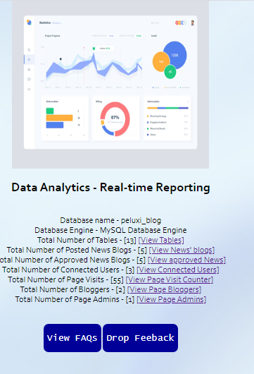

The System automatically gives some analytics on various parts of the Data Analytics Application such as the total number of posted news blogs as you can find on the above snapshot. The figure increases dynamically as the number of posted news blog increases. The same thing applies to the rest of the Data Analysis.

In conclusion, the SySSaS Data Analytics System is very rich in functionality, context and characteristic features. The Application indeed has a lot of Visualized functionalities and offers some advanced data reporting capabilities and functionality. It provides some powerful insights into blog development techniques and methodology.